**School Canteen’s Food Menu and It’s Relationship to Student’s Daily Allowance**

A Quantitative Research Presented to

The Faculty of Senior High School Department

In Partial Fulfilment of

the Requirements in the Subject

Practical Research 2

January 2023

**By:**

**Franco Grace Anne B.**

**Mangrobang, Ervin Joshua**

**Marzan Iverson R.**

**Mingo Anne Gwyneth L.**

**APPROVAL SHEET**

II

This research entitled **“School Canteen’s Food Menu and It’s Relationship to Student’s Daily Allowance”** prepared and submitted by Iverson R. Marzan, Grace Anne B. Franco, Ervin Joshua Mangrobang, and Anne Gwyneth L. Mingo in partial fulfillment of the requirements for Practical Research 2 of Senior High School, has been examined and recommended for final examination for the first semester.

Jaime Boy A. Alegre, PhD

Research Adviser

Ramona A. Villanueva, EdD

SHS Focal Person

**PANEL EXAMINERS**

Approved by the Committee on Final Defense with a grade of ______ on   
February 2023.

_________________ _________________ _________________  
Darryl G. Bayona Analyn DG. Fabian Shirbenly Y. Garcia  
 Teacher III Master Teacher 1 Master Teacher 1

Accepted and approved in partial fulfillment of the requirements for the Practical Research 2 of Senior High School Department.

AKNOWLEDGEMENT

III

First and foremost, we give thanks and gratitude to God, the Almighty, for guiding us and enabling us to successfully complete our research.

Researcher would like to express their gratitude to Mr. Jaime Boy A. Alegre, for giving us the opportunity to do research and also for his motivation, patience and assistance to accomplish the study.

Our thanks and appreciation also go to Sir Marlon L. Lalaguna for validating our research and for the constructive criticism that help our study to be better.

The researchers would also like to express their gratitude to Ma'am Ramona A. Villanueva for unwavering support to our study.

Researcher would also like to give thanks to the School Principal for allowing the researcher to conduct the study and stay within the school.

Researcher would also like to thank the Panelist, for giving us opportunity to present our study.

For our dearest respondents, the participation and willingness to answer the questionnaire help us to determine the data. And we, appreciate and grateful to all the cooperation.

IV

Last but not least, I want to express my gratitude to my teachers, friends, and family for their care, assistance, patience, and other forms of support. These things motivate and help researcher to persevere the succeed in this study.

ABSTRACT

V

This study entitled “School Canteen Food Menu and It’s Relationship to Student’s Daily Allowance.” Researchers found out that Student’s Daily Allowance as well as the menu at the school Canteen are both important because the canteen is one of the places where they spend their money. It assists pupils in choosing the food they wish to eat. Researcher also distributed the 75 questionnaires to the Grade 8 and 9 junior high school to determine their answers on how School Canteen Food Menu has relationship to Student’s Daily Allowance. The survey questionnaire will be the main tools of the study. The first part of the questionnaire is the ranges of Student’s Daily Allowance, and the second part is to describe the food canteen’s menu in terms of Affordability, Food quality, and Varieties of food. The total respondents are 75 or 100%. Researchers use Statistical tools which Percentage distribution to determine the ranges of Students Daily Allowance. Weighted mean, use to describe the school Canteen in terms of Affordability, Food quality and Varieties of food. Last, Pearson’s r uses to determine the relationship between School Canteen Food Menu and Student’s Daily Allowance. The result of this findings is School canteen menu have a low impact on how they allocate their Students Daily Allowance because there is a very low correlation between the two variables which means they have a significant relationship but not much. This study recommends the future researcher to obtained more than 75 respondents to get more accurate data.

**KEYWORDS:** School Canteen Menu, Students Daily Allowance

**TABLE OF CONTENTS**

VI

Title Page…………………………………………………………………………. I

Approval Sheet…………………………………………………………………… II

Acknowledgement………………………………………………………………... III

Abstract…………………………………………………………………………… V

Table of Contents…………………………………………………………………. VI

**Chapter 1: The Problem and its Background**

Introduction ………………………………………………………………………. 1

Background of the study …………………………………………………………. 2

Significant of the study ……………………………………………………………3

Statement of the problem …………………………………………………………. 4

Hypothesis ………………………………………………………………………… 5

Scope and Delimitation ……………………………………………………………. 5

**Chapter 2: Review of Related Literature and Studies**

Review of Related Literature and Studies ………………………………………… 6

Synthesis of Related Literature …………………………………………………… 12

Conceptual framework …………………………………………………………… 13

Definition of terms ……………………………………………………………….. 14

**Chapter 3: Research Design and Methodology**

Research Design ………………………………………………………………….. 15

Respondent of the study ………………………………………………………….. 16

Research Instrument ………...……………………………………………………. 16

Data Gathering Procedure ………………………………………………………... 17

Statistical Analysis ………………………………………………………………..18

**Chapter 4: Presentation, Analysis and Interpretation of Data**

VII

Presentation, Analysis and Interpretation of Data………………………………. 21

**Chapter 5: Summary of Findings, Conclusion and Recommendation**

Summary of Findings…………………………………………………………… 32

Conclusion ……………………………………………………………………… 33

Recommendation ……………………………………………………………….. 34

Bibliography ……………………………………………………………………. 35

Appendices ……………………………………………………………………… 37

Curriculum Vitae………………………………………………………………… 42

VIII

LIST OF TABLES

Table 1: Distribution of ranges students daily allowance………………………….. 22

Table 2: The food in the school canteen be described in terms of

Affordability ……………………………………………………………………….. 24

Table 3: The food in the school canteen be described in terms of

Quality of Food …………………………………………………………………….. 26

Table 4: The food in the school canteen be described in terms of

Variety of Food …………………………………………………………………….. 28

Table 5: Significance relationship between the school canteen menu and their daily

allowance as a student’s …………………………………………………………….. 30

VIIII

LIST OF FIGURES

Figure 1: Paradigm of The Study …………………………………………………. 13

**CHAPTER-1**

Page | 1

**The Problem and Its Background**

This chapter presents the Introduction, Background of the study, Statement of the problem, Hypothesis, Scope and Delimitation, and Significant of the study.

**Introduction**

School Canteen are preparing foods that they enjoy students might eat their school lunches more frequently. Additionally, providing students with periodic nutrition instruction and nutritionally balanced meals through the school meal program might aid them in developing the necessary knowledge and motivation to select the best foods for their health. The menu served by the food stalls in the canteen consisted of main and side dishes. Information on the ingredients, including the average weight of each ingredient, was collected twice on different days. The quantity of each ingredient was measured using a standard kitchen weight scale

School allowance refers to finance for students when they are in school. Allowance has a significant role when students buy their requirements for a particular subject. Allowance of the students may determine their interest on studies. It is interesting to know if students may determine if they have enough allowance. Parents provide allowance for students. It is very important to know whether socioeconomic status affects the performance and the determination of the students.

School canteen menu and their daily allowance are both important because the canteen is one of the reason why students spend their daily allowance in school. It help students to determine what food they want to eat

Page | 2

This study aimed to know the relationship between school canteen menu and daily allowance of junior high school students

**Background of the Study**

School Canteen are important to establish because it gives students enough food to support their physiological development and learning.

According to DepEd (2007) The canteen's menu should have healthy foods and have at least consideration on having an affordable price. And also, it should keep us full and give nutrition and energy to student. Make available healthier food and beverage choices among the learners. It is important to achieve dietary energy balance coming from the intake of carbohydrates, fats, and protein to maintain a healthy weight.

According to The Ministry of Health in Singapore, they strive to keep canteen food prices affordable. They intend to balance the food pricing while maintaining a variety of options. This is what student wants because most students don't have enough money, and a lot of them are going to school without anything to eat

Mensink (2012) argues that the environment has a significant impact on people's dietary choices. It is crucial that the school food environment be healthful in order to encourage children to make more healthy food choices and build healthy eating habits.

Page | 3

An independent research organization carried out a study to ascertain the opinions, perceptions, and experiences of program participants (school directors, parents, students, and health professionals). Results indicate that administrators and students at participating schools believe the cafeteria selection is healthier now than it was before the program was put into place. The study's additional significant findings are then emphasized, and their connections to other projects, warnings, and helpful recommendations are explored. The Healthy School Canteen program is a promising strategy to alter the environment of school food, but further study is required to determine its effectiveness. Additionally, it will be difficult to persuade all schools to sign up for the program in order to accomplish the goal.

**Significant Of the Study**

This study was conducted to determine the School canteen Food menu and It's relationship to Students daily allowance. The study results may be beneficial to the following:

Students - It would help students to be aware of proper services and also the good quality of foods that should be provided by the school. This study would be beneficial to students for them to understand the realities of the canteen operations and the basic services that are expected to be provided by the school.

Canteen Staff - To improve their canteen's menu services and quality of food and also to be aware of what food is always students like. This may provide the necessary data for the canteen staffs to identify their priority areas of improving the canteen menu to better serve its customers students.

Page | 4

Researchers- This may serve as the basis for those research enthusiasts to conduct a further inquiry regarding the canteen menu and student satisfaction.

**Statement of the Problem:**

This study aimed to know the relationship between school canteen food menu and their daily allowance as of junior high school students . Specially, the study sought to answer the following question:

1. How may the food in the School Canteen be described in terms of:
   1. Affordability
   2. Quality of food
   3. Variety of food
2. What is the Daily Allowance of the Students?

2.1 ₱10 - ₱60

2.2 ₱61 - ₱110

2.3 ₱111 - ₱160

2.4 ₱161 - ₱210

3. Is there significant relationship between the School Canteen food menu and Student’s Daily Allowance?

This study is tested at 0.05 level of significant

Page | 5

**Hypothesis**

There is no significance relationship between the School Canteen food menu and Student’s Daily Allowance?

**Scope and Delimitations:**

This study entitled "School Canteen’s food menu and It’s Relationship to Students’ Daily Allowance” It aims to identify the School Canteen’s food menu. And how it have a Relationship to Student’s Daily Allowance. Moreover, this study has 75 respondents of students at Gent De Leon National High School who are currently enrolled for the school year 2022-2023 and the respondents will be grade 8 and grade 9.

**CHAPTER-2**

Page | 6

**Review of Related and Studies**

This chapter gives emphasis on Related Literature, Conceptual Framework, Synthesis of Related Literature and Definition of Terms.

**Related Literature**

Godfrey, (2013) Students need a location to keep their money so they can pay for their wishes or essentials. On the other hand, students learn to save their allowances as they get older and encounter new scholastic necessities as well as products they want to buy on their own. The allowance for students might change depending on a variety of factors. anything, including one's diet and tuition. Simply said, one cannot just buy allowances and ignore the problem. Students spend their money on a range of things, such as their favourite cuisines, transportation fees to and from school, as well as sporadic extra expenses related to their academics. Budgeting, saving, investing, and using cash are all aspects of good money management. Although they are not something we are born with, they are something that is gained over the course of a lifetime through a variety of achievements and failures. "An allowance is not a pay or an entitlement. Money is given as an allowance. "It is a tool for teaching kids how to manage money.

Students spend their money on a variety of items, including the foods they enjoy, the cost of transportation from their homes to school and back, and sporadic extra costs associated with their studies that may call for quick payment. So it is clear how readily a student's money is wasted. This study is relevant to ours because it focuses on the management skills needed to effectively budget our daily allocation as students, and because it gives us some insight into how they do it. Several variables have an impact on our allowance. Our spending plans are impacted by our food preferences since they reflect our wants and needs. Because they will likely have saved money if they have good money management abilities in the way we budget, save, invest, and use our cash.

Page | 7

Jabir (2015) discovered that pure vegetables, along with halwa/kheer and rice, were the respondents' top choices, with pulses/vegetables/kadi coming in second. Pure veggies were shown to be the respondents' top preference when asked more specifically about the kinds of menu alterations they sought. According to the article, the majority of Indian kids prefer eating vegetables than junk food. Because junk food is still popular in nurseries, elementary schools, and even high schools when you first start to develop. Indian students are now requesting vegetables and nutritious cuisines. Because students have distinct preferences for junk food and healthy food, it has relevance to our study. Therefore, it aids in identifying the menu items that students preferred at the school canteens. Additionally, it has added an aspect of originality by allowing us to examine a wide range of customer-related factors like preference, trustworthiness, and personal preference. In addition to being a good habit, keeping a tight rein on your monetary outlays and limiting how much you spend helps you achieve financial success, which will be crucial in the future

Manju, (2016). Given the larger role that adolescents play in our society, it is crucial to keep an eye on how they behave when it comes to money. Budgeting, saving, investing, spending, and keeping track of the total amount of money used all take time. According to the report, students spend more money on fast food, pleasure trips, and internet activities than on books, savings, and other things. Most people rely on their parents to see them through each day. Only half of them use a budget, but more than 90% keep their spending under control. Students' daily allowances have a great role in student's success. Because, if you know how to control yourself to spend the money that you had then the behaviour leads to financial aspects which assess the economic viability of a proposed venture by evaluating the start-up costs, operating expenses, and cash flow and making a forecast of future performance.

Page | 8

According to Amelia and Garg (2016), One of the most important factors, in addition to the quality of the food, the amount of time spent waiting for the food to be served, the correctness of the food served, and the staff's politeness and alertness, is the first impression. The customer's intention to return to the canteen was significantly influenced by the ambience and comfortable seating. This study focuses more on how a restaurant's first impressions are formed; As a result, restaurateurs will be able to capitalize on a customer's favourable first impression. This study referenced and utilized theories related to the subject at hand, experts' opinions, and previous studies.

Consequently, many Canteens have generally poor service, as students account for the majority of users of institutional food services, particularly in university and college dining; student satisfaction in university cafeterias is becoming increasingly popular and significant. The quality of the food and beverages served in university cafeterias, the variety of options for food and beverages, and price and value fairness all contribute to students' satisfaction.

Mone a, J., Tuñacao, M. (2020) most of the students received their allowance in a daily basis. The allowances are used for their everyday consumptions and to use for their needed in school. Students will appeared to have an peaceful of thoughts for their financial lifestyles due to have a meeting of financial duties with much less level of debt. For the remaining the money they have can bought something and to save money for future. For the use of budgeting the technique to do that a students used it is a proportional type of the budgeting as to their allocated allowances based on the percentage. Due to their meagre stipend, students typically purchase food because it is affordable and delectable, claims

Page | 9

Namco et al. (2022). The food's nutritious content is the last thing they take into account. This study suggests snack options that will satisfy the students' financial needs while also meeting the food's nutritional and palatability requirements. This study, which involved 1364 teenagers from various public high schools in Cagayan de Oro City, Philippines' East II District, sought to learn more about the parents' sources of income, the daily allowance given to the participants for school snacks, the most popular foods they selected, and the motivations behind those selections. The problem of a student not finding this snack nourishing, affordable, and of high quality will be resolved if we conduct the snack that will give student satisfaction, And it is not simply snacks since it contains a full of healthy foods. It should be Affordable, since not everyone has the financial means to purchase a costly one, and many pupils lack that opportunity. The study's findings support the notion that students make socioeconomic plans for eating out, that wonderful flavour influences attitudes and assessments, that budgeting influences behavioural intent, and that carrying a bag along and budgeting influence actual behaviour.

Delayco, (2015) The pattern of correlations within a collection of observed variables is explained using the underlying variables of students' budgeting and eating-out behaviour. A factor analysis verifies the anticipated variables using an administered survey and data analysis produced by the Statistical Package for Sciences (SPSS) software. Taking the following group of observed variables into account (such as meal planning, budget constraints, proximity, and enjoyment in eating out, attitudes towards eating out, beliefs, and evaluations) It asserts that decisions, attitudes, behaviour, and beliefs are what determine how food is prepared and consumed by an individual. Students, which are surrounded by a variety of eateries, make these dietary decisions every day. And it's important to understand how these food choices are made because this article aims to understand how students manage their finances and eat out without buying nutritious food.

Page | 10

According to Ryan Tam, et al. (2017) That there is a demand for healthy food and that price gouging is a key lever for change. Although it may be useful to plan interventions at other universities, this information will be used to alter the local university's food environment. 93% of students purchased food or beverages on campus, with sandwiches and hot beverages being the most popular selections. The primary considerations in choosing a meal were flavour, price, value, and convenience. Female students engaged in more particular dietary practices and accorded health-related factors more weight than male students did. The two suggestions that were made the most frequently were to lower the price and broaden the selection of foods. According to this report, the majority of people desire to eat healthily, but they also need to take price into account. The two suggestions that were made the most frequently were to lower the price and broaden the selection of foods. These are some potential methods for promoting healthy eating at university dining halls.

Carlos (2021) The concept also made it feasible to develop a variety of meals over the course of the approached time in accordance with the students' food preferences, which was the study's unique addition. It is concluded that the mathematical model can help nutritionists create menus for university eateries and that it can be modified for usage by a different audience while still meeting their nutritional needs.

Page | 11

This study refers to developing a menu plan, seeking to formulate nutritionally adequate meals that meet students' dietary preferences at the lowest cost. This has relation to our study which is the student preferences because it can be able to assist nutrition professionals in the development of menus for the School canteen, and it can be adapted for use by another audience taking into account the adequacy of nutritional requirements.

Barreto, Et al. (2018) demonstrated that students need to budget their allowances with knowledge and discipline. Parents should supervise and advise their children on how to manage their allowances as well as other student expenses that may have an impact on their allowance for meals and transportation. Teachers might also go over some advice for allocating allowances properly based on the available funds. In order to provide useful advice on how they will appropriately budget their allowance, this study concludes by recommending additional research on the range of senior high school allowance. People have always included budgeting in their daily lives. It is always present; some people have adequate resources, while others do not. Depending on a person's station in life, their expenses likewise vary. Students who get a weekly allowance sometimes struggle to manage their money well. This study aims to determine how poorly allocated allowances affect the academic achievement of students. This study examined the impact that poor budgeting has on the academic achievement of students using a qualitative approach and a descriptive research methodology.

**Synthesis of Related Literature**

Page | 12

In summary students satisfaction is also influenced by the standard of the food and drinks supplied at cafeterias. It's important to students to provide useful instructions on how they will correctly budget their money. Budgeting has long been a part of daily life for people. It is always there, but not everyone has access to enough resources.

Students are more likely food primarily because it is cheap and delicious. The nutrient contents of the food are the least that they consider. According to Namco et al. (2022) and the first impression is one of the main considerations along with the quality of food, waiting time for the food being served, the correctness of the food served, and politeness and alertness of food canteens staff. And it’s important to students to provide useful instructions on how they will correctly budget their money. Budgeting has long been a part of daily life for people. It is always there, but not everyone has access to enough resources

**Conceptual Framework**

Page | 13

**Students Daily Allowance**

* ₱10 - ₱60
* ₱61 - ₱110
* ₱111 - ₱160
* ₱161 - ₱210

**School Canteen Food Menu**

* Affordability
* Quality of Food
* Varieties of food

-Affordability

-Profitability

-Quality of Food

- Personal choice

*Figure 1. Research Paradigm*

The research paradigm illustrates the conceptual framework of the study that shows the relationship of dependent and independent variable of the topic. In the part of independent variable shows the School Canteen Food Menu that consisting of the following: Affordability, Quality of Food and Varieties. On the other side, the dependent variable its show the ranges of daily allowance of students

Page | 14

**Definition of Terms**

School canteen - wherein the students purchased a healthy and nutritious food.

Food menu - in which the students preferred cheap food at a price that they could be afford.

Daily Allowance(s) - it is the amount of money that students were entitled and how they handled it on a day-to-day basis.

**RESEARCH CHAPTER -3**

Page | 15

**Research Design and Methodology**

This chapter presents the research design, respondents of the study, Research instruments, Data Gathering Procedure, and Statistical Analysis tools that will used in identifying The Relationship between the school canteen food menu and to Student’s Daily Allowance

**Research Design**

Descriptive research is designated as a research method that will delineate the characteristics of the population or the phenomenon of an study, and to tackled of the educational settings to do they described, to compare, contrast, classified, and to analyse how will they interpret the institution and circumstances, This methodology distinct more on the “what” of the research and also the “why” of the research subject (Siedlecki, 2020). According to Creswell (2003), portrays methodology as a consistent group of methods that systematize one another and that have the proficiency to fit to deliver data and findings that will indicate the research of a question and to suits the researcher’s purpose In this methodology, it is says a group which is to have an systematize, and also it may include that having an proficiency to fit on how you will deliver the data and what is the method on how you will find on it. A study of a methodology, it must be known, how indicated of a research questions to will it be suits of the researcher's purpose The researcher must use a descriptive research design and to think of it, how will describe may the food in the School Canteen be described in terms of: Variety of food, Quality of food and Affordability

**Respondents of the study**

Page | 16

General Tiburcio de Leon national high school is the public school founded in 1969. It’s located at corner Mercado Street along gen t Deleon road Valenzuela. Its location has been moved several times from Tañada subdivision to its current location in Mercado Street near t Bugallion Bridge

The researcher uses the Junior high school in Gent De Leon National High School to be the respondents of our study. Because, the researcher needs to know the relationship between school canteen food menu and students daily allowance. And it has a total of 75 junior high school students. The researchers use the random sampling method. And, researcher may provide the questionnaire to conduct it in every Grade 8 and Grade 9 students.

|  |  |  |
| --- | --- | --- |
| **Respondents** | **No. of responded** | **Percentage** |
| Grade-8 | 53 | 71% |
| Grade-9 | 22 | 29% |
| Total | 75 | 100% |

**Research Instruments**

The research instruments or tools used in this study are a survey questionnaire. A questionnaire is a list of questions or items used to find out what people think, feel, or think about certain things. Polls can be utilized to gather quantitative or potentially subjective data. When using a questionnaire for survey sampling, it's critical to make sure it's made to get the most precise responses from respondents.

The first part of the questionnaire includes the school canteen food menu and the second part includes ranges of their daily allowance as a students. The Likers scale was used to identify the School canteen food menu, where 0.01 - 1.00 = strongly Disagree, 1.01 - 2.00 = Disagree, 2.01 - 3.00 = agree 3.01 - 4.00 = strongly agree. In the questionnaire, it must be have the responses of strongly agree (SA), agree (A), Disagree (D), strongly disagree (SD) with the equivalent verbal interpretation.

Page | 17

**Data Gathering Procedure**

The researchers went to the building A in Gent De Leon National High School to ask the every head teachers to find out the number of students of grade 8. But, When the Researcher came. The head teachers are not there. So, researcher decided to go in Building B to find other Head teachers. Then, The Head teachers told the Researcher to go in the SBM office. So, it could be more quickly to find out the number of the students. Then, the coordinator gave the number of list of grade 8 and 9. Researcher decided that the survey questionnaire will be distributed by 2 sections in Grade 8 and 9.

|  |  |  |
| --- | --- | --- |
| **Responses** | **Verbal Interpretation** | **Likers Scale** |
| SA | Strongly Agree | 3.01 - 4.00 |
| A | Agree | 2.01 - 3.00 |
| D | Disagree | 1.01 - 2.00 |
| SD | Strongly Disagree | 0.01 - 1.00 |

**Statistical Analysis**

Page | 18

The following statistical tools were utilized towards systematic presentation of the findings of the study.

**Weighted Mean -** This was used in problem number 1 in order to get the average value of the answers that the researcher collected from junior high school students from describing a school canteen food menu.

Formula: WM =

Where in: WM = Weighted Mean

fi = Frequency

x = weighted assigned

n = sample size

∑ = summation

**Percentage Frequency Distribution** - It is used in problem number 2 to present of a data that make it prescribe the percentage of observation for they subsist a group of a data point. Researcher makes an observation to know the range of the respondents. And, it can be used to obtain the percentage of frequency distribution of how much is their daily allowance

Formula: % x 100

Page | 19

Where: % = Percentage

F = Frequency

N = Number of Cases

**Pearson’s r** this statistical tool measures the strength and the direction of the linear relationship of the two variables and of the association between interval and ordinal variables.   
   
Formula: 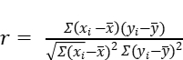

Where in:   
 r = correlation coefficient   
 Description: C:\Users\marlo\AppData\Local\Temp\ksohtml12852\wps24.jpg = values of the y-variable in a sample  
 Description: C:\Users\marlo\AppData\Local\Temp\ksohtml12852\wps25.jpg = values of the x-variable in a sample.   
 Description: C:\Users\marlo\AppData\Local\Temp\ksohtml12852\wps26.jpg = mean of the values of the y-variable.   
 Description: C:\Users\marlo\AppData\Local\Temp\ksohtml12852\wps27.jpg = mean of the values of the x-variable

Page | 20

This study use the Microsoft word to perform the formulas given from percentage frequency distribution, weighted mean and Pearson’s r

**CHAPTER-4**

Page | 21

**Presentation, Analysis and Interpretation of Data**

This chapter presents, analysis the findings of the study together with the interpretation of the data for the purpose of answering the specific questions posted in the statement of the problem about. The School Canteen’s Food Menu and It’s Relationship to Student’s Daily Allowance

The data obtained from the questionnaire included the School Canteen’s Food Menu and It’s Relationship to Student’s Daily Allowance for affordability, food quality, and personal choice.  The data are organized in tabular form and the problem were treated and discussed in the manner that they were presented in the statement of the problem for the direct reference, appropriate analysis and interpretation.

**Table 1**

Page | 22

*The amount of student’s daily allowance in school canteen of Gen. Tiburcio Deleon National High School*

|  |  |  |
| --- | --- | --- |
| Percentage  *Range of* their *daily*  *allowance*  Frequency | | |
| ₱10 - ₱60 | 41 | 54% |
| ₱61 - ₱110 | 30 | 40% |
| ₱111 - ₱160 | 2 | 3% |
| ₱161 - ₱210 | 2 | 3% |
| Total | 75 | 100% |

*Table 1. Percentage Distribution*

*Note.* table 1 shows the amount of their daily allowance for school food menu based on the ranges of their allowance. 41 or 54% of the respondents has ranges of 10-60 allowance, and 30 or 40% of the respondents have ranges of 61-110 and in the ranges of 111-160 have an 11 or 15% of the respondents answer same with the ranges of 161-210 allowance, for a total of 75 or 100% of respondents. This data shows that many of the students have different daily allowance when it comes to food cycled menus, but in this case, the ranges of 10-60 got a higher frequency or have a lot of students to choose from.

According to the study of Ferlyn S Paraunda (2019) 1 or 0:85% of the respondents has the pocket money of P15.00, P35.00, P75.00, P90.00, P110.00, P150.00, P200.00, P250, P500.00, 2 or 1 71% of the respondents has the pocket money of P2000, 4 or 3 42% of the respondents has the pocket money of P30 00, 8 or 6.84% of the respondents has the pocket money of P40.00, 48 or 41.03% of the respondents has the pocket money of P50 00, 7 or 5 98% of the respondents has the pocket money of P60.00, 12 or 10 26% of the respondents has the pocket money of P70.00, 6 or 5 13% of the respondents has the pocket money of P80.00, and 21 or 17 95% of the respondents has the pocket money of P100.00. These data shows that most of the students has the pocket money of P50.0

Page | 23

**Table 2**

Page | 24

*Describing the affordability in school canteen food menu*

|  |  |  |
| --- | --- | --- |
| **Affordability** | **Weighted mean** | **Verbal Interpretation** |
| 1. I buy foods in the school canteen that is enough for my daily allowance. | **3.25** | **Strongly agree** |
| 2. I can buy the food in canteen at the lowest possible price. | **3.18** | **Strongly agree** |
| 3. I prefer food that has large quantity because it is convenient to my daily allowance. | **2.88** | **Agree** |
| 4. I buy the biscuits and juices within the range of my daily allowance. | **2.85** | **Agree** |
| 5. I check the price first before buying foods from the canteen. | **3.64** | **Strongly agree** |
| **General Weighted Mean** | **3.16** | **Strongly agree** |

0.01- 1.00 = strongly Disagree , 1.01 - 2.00 = Disagree

2.01 - 3.00 = agree 3.01 - 4.00 = strongly agree

*Note.* the table 2 shows that for the questions I buy foods in the school canteen that is enough for my daily allowance and I can buy the food in canteen at the lowest possible price and I check the price first before buying foods from the canteen to make sure that it is affordable had a weighted mean of 3.25, 3.18 and 3.64 respectively with the verbal interpretation of strongly agree. The data shows that the respondents are strongly agree that before they buy in school canteen they will check the affordability of the food towards in the canteen menu because most of them answered strongly agree. And for the question of I prefer food that has large quantity because it is convenient to my daily allowance and I buy the biscuits, junk foods, candies and juices within the range of my daily allowance had a weighted mean of 2.88 and 2.85 respectively with a verbal interpretation of agree. With a general weighted mean of 3.16 respectively with a verbal interpretation strongly agree

Page | 25

According to the study of research on the allowance and budgeting of grade-12 students in assist main campus by Daodaoen (2018) they illustrates the overall mean of all the statements under "meal." It can be inferred. that senior high school students frequently eat their breakfast at home before going to school Expenses, with a mean as a whole of 2.92, and spending 40–50% of their allowance on food The overall mean is 2.78, which is second to the most significant. It is also frequent for senior high School students are encouraged to bring a packed lunch to save money, with a mean total of 2.75. Senior high school students rarely eat outside the school, with a mean overall of 2.47. Affordable food options and bringing a packed lunch or food because it is not provided allowance, with a mean total of 2.45.

**Table 3**

Page | 26

*Describing the Quality of food in school canteen food menu*

|  |  |  |
| --- | --- | --- |
| **Food quality** | **Weighted mean** | **Verbal Interpretation** |
| 6. I check how long the food will last take before I buy in the school canteen. | **3.12** | **Strongly agree** |
| 7. I prefer the food that is clean. | **3.76** | **Strongly agree** |
| 8. I prefer food that looks tastier in school canteen but appropriate in my daily allowance. | **3.16** | **Strongly agree** |
| 9. I prefer the food that is inside a good packaging and that is sufficient to my daily allowance. | **3.29** | **Strongly agree** |
| 10. I prefer the product that is nutritious. | **3.51** | **Strongly agree** |
| **General Weighted Mean** | **3.37** | **Strongly agree** |

0.01- 1.00 = strongly Disagree , 1.01 - 2.00 = Disagree

2.01 - 3.00 = agree 3.01 - 4.00 = strongly agree

*Note.* the table shows that for the questions I check how long the food will last take before I buy in the school canteen, I prefer the food that is clean, I prefer food that looks tastier in school canteen but appropriate in my daily allowance, . I prefer the food that is inside a good packaging and that is sufficient to my daily allowance and I prefer the product that is nutritious had a weighted mean of 3.12, 3.76, 3.16, 3.29 and 3.51 with a verbal interpretation of strongly agree the data shows that the students when it comes to food in the canteen menu quality of the food they consider when they buy in school canteen but sufficient to their daily allowances because most of them answer strongly agree.

Page | 27

According to Ferlyn S. Paruada (2019) the canteen's cleanliness is well maintained, the chairs and tables are organized and properly arranged. The canteen's ambiance is very welcoming for the students. The ambiance of the canteen is good and refreshing. The canteen is strategically situated in a place where it is accessible and convenient to all the students and the canteen is well-organized and well-managed had a weighted mean of 4.16, 4.25, 40.7, 3.98, 4.05, and 4:.5 respectively with a verbal interpretation of Agree. The data shows that the respondents prefer the ambiance of the Teachers' Cooperative Canteen because most of them answered Agree

**Table 4**

Page | 28

*Describing the Varieties of food in school canteen food menu*

|  |  |  |
| --- | --- | --- |
| **Variety of Food** | **Weighted mean** | **Verbal Interpretation** |
| 11. I choose the cheapest food in the canteen. | **2.83** | **Agree** |
| 12. I prefer foods with soup over fried foods. | **2.65** | **Agree** |
| 13. To save money, I would rather bring my own rice and purchase some meals in school canteen that fit within my daily budget. | **3.08** | **Strongly agree** |
| 14. I prefer water than juice because it is healthier and more affordable. | **3.31** | **Strongly agree** |
| 15. I bring my own food so that I don’t have to spend a lot of money in buying food at the school canteen. | **3.91** | **Strongly agree** |
| **General Weighted Mean** | **3.16** | **Strongly agree** |

0.01- 1.00 = strongly Disagree , 1.01 - 2.00 = Disagree

2.01 - 3.00 = agree 3.01 - 4.00 = strongly agree

*Note.* the table shows that for the questions I choose the cheapest food in the canteen and I prefer foods with soup over fried foods had a weighted mean of 2.83 and 2.65 respectively with a verbal interpretation of agree. And for the questions To save money, I would rather bring my own rice and purchase some meals in school canteen that fit within my daily budget, I prefer water than juice because it is healthier and more affordable and I bring my own food so that I don’t have to spend a lot of money in buying food at the school canteen had a weighted mean of 3.08, 3.31 and 3.91 respectively with a verbal interpretation of strongly agree. The data shows that they consider their varieties of food when it comes to food canteen menu when they buy in school canteen.

Page | 29

According to the study of research on the allowance and budgeting of grade-12 students in assist main campus by Daodaoen (2018) the overall mean of statements under "Savings." Getting the highest mean 2.84 of respondents save money for emergencies or just in case they need it. Next, with a whole mean of 2.80, students allocated 10–20% of their allowance for savings. With a whole-group mean of 2.65, the respondents lent part of their allowance rather than spending it. Opening a bank account or having a treasure box where they can deposit their savings with a whole mean of 2.13 and a whole mean of 1.19, being the lowest senior high School students answered that they join the ease-up system or Paluwagan.

**Table 5**

Page | 30

*The significance relationship between the school canteen menu and their daily allowance as a students*

|  |  |  |  |  |  |
| --- | --- | --- | --- | --- | --- |
| **Describing the food in canteen menu** | **Their Daily Allowance** | **r value** | **P value** | **Remarks** | **Decision** |
| Affordability | Daily allowance | 0.048396 | 0.680702 | Accept the null hypothesis | Not significant |
| Quality of food | 0.174576 | 0.134303 |
| Varieties of food | 0.052251 | 0.656482 |

0 < r 0.19 = Very Low Correlation 0.6 r 0.79 = High Correlation

0.2 r 0.39 = Low Correlation 0.8 r 1.0 = Very High Correlation

0.4 r 0.59 = Moderate Correlation

*Note.* table 5 presents the significant relationship between the food canteen menu and their daily allowance. The table shows the pearsons r of the three (3) prescribe in school canteen menu such as affordability, food quality and varieties of food has a low correlation to their daily allowance.Because in affordability the r value is 0.048396 and in quality of food have 0.174576 while in personal chocie is 0.052251. The result is very low correlation, so the data shows that the students preferences has low effects to the way students budget their daily allowance.

According to study of Bautista Ronyth Francette N. (2019) The results of their study was interpreted as low positive relationship. It illustrated that there was a low significant relationship between the two variables. Despite having low or small allowance, there were respondents who had big savings. Similarly, respondents who had a large allowance were not able to save lots of money. Therefore, this meant that the amount of the respondents’ daily allowance did not necessarily have a direct relationship to the budget and savings of a person.

Page | 31

**CHAPTER-5**

**Summary of Findings, Conclusion and Recommendation**

This chapter presents the summary of the findings, conclusion and recommendation of the study

**Summary of Findings**

The objective of this study was to determine the relationship of School Canteen’s Food Menu and I Student’s Daily Allowance.

1. There were 41 or 54% daily allowance in a range of 10-60 pesos, 30 or 40% daily allowance in a range of 61-110, 2 or 3% daily allowance in a range of 111-160, 2 or 3% 161-210 with the total of 75 or 100% respondents.

2. In Affordability the highest result of weighted mean is 3.64 which is I check the price before buying foods from the canteen to make sure that is affordable

3. In Food quality the heighest result of weighted mean is 3.76 which is I prefer the food tha`t is clean.

4. In Variety of foods the heighest result of weighted mean is 3.95 whic is I bring my own food so that I don’t have to spend a lot of money in buying food at the school canteen.

5. The Affordability, Food quality and variety of foods in r-value have a very low correlation, while in p-value have a significant but not and accept the null hypothesis so it means that the canteen food menu and students daily allowance have low correlation or relationship

Page | 32

Page | 33

**Conclusion**

Based on the findings the following conclusion are illustrated below

1. Students or respondents have a range of 10 to 60 pesos in their daily allowance.

2. Based on findings, the total average or grand weighted mean for the affordability is 3.16 which means that all of the respondents are they considered the afforability of the food to make sure that is suited to their daily allowance and they will check the price first before buying foods from the canteen to make sure that is affordable

3. Based on findings, the total average or grand weighted mean for the food quality is 3.37 which means that all of the respondents are they considered the quality of food when they buy in school canteen because they make sure the cleanliness of the food

4. Based on findings, the total average or grand weighted mean for the Variety of foods is 3.16 which means that all of the respondents or students are they considered their personal choice when it come of food when they buy in school canteen because some of the students choose to bring their own food so that they don’t have to spend a lot of money in buying food at the school canteen.

5. School canteen menu have a low impact on how they allocate their Student's daily allowance because there is a very low correlation between the two variables which means they have a significant relationship but not much

**Recommendation**

Page | 34

The following recommendation are offered that will serve as guidelines for the students, teachers, principal, staffs and future reseachers. In light of the findings and conclusion of the study the following recommendations were drawn

1. For future researcher, this study recommends obtaining more than 75 respondents and other grade levels could be potential research participants.

2. This study recommends students to conduct a survey on food preferences about adding new items to the menu.

Page | 35

**BIBLIOGRAPHY / REFERENCES**

Barreto, Et al. (2018) *Improper Budgeting of Allowance and its Effects in the*

*Academic Performance of Grade 12 ABM Students in Bestlink College of the*

*Philippines School Year 2018-2019.* https://ojs.aaresearchindex.com›.

vi...Improper Budgeting of Allowance and its Effects in the Academic ...

Retrieved on October 27, 2022.

Carlos G. (2021) *College Students and Eating Habits: A Study Using An*

*Ecological Model for Healthy Behavior.* https://www.mdpi.com › ... College

Students and Eating Habits: A Study Using An Ecological Model ... Retrieved

on October 27, 2022.

Catanzaro D. (2013) *Relationship between food preferences and PROP taster*

*status of college students.*  https://pubmed.ncbi.nlm.nih.gov › ...Relationship

between food preferences and PROP taster ... Retrieved on October 27, 2022.

Delayco M.(2015) *Understanding the Budgeting and Eating Out Behavior.*

https://www.dlsu.edu.ph › 10...PDF Understanding the Budgeting and Eating Out

Behavior of ... Retrieved on October 27, 2022.

Page | 36

Garg A. (2016) *Exploring customer satisfaction with university cafeteria food*

*services. CyberLeninka Open Science Hub* https://cyberleninka.org › article

Exploring customer satisfaction with university cafeteria food services. ...

Retrieved on October 27, 2022.

Godfrey Et al. (2013) *Good money management skills.*

https://www.coursehero.com/file/p2gtt7r9/According-to-Godfrey-2013-good-

money-management-skills-are-the-process-of/ Retrieved on October 27, 2022.

Jabir A. (2015) *Adoption of diversification for risk management in vegetable*

*Cultivation.*https://scholar.google.com/scholar?hl=en&as_sdt=0%2C5&q=jabir+

%282015%29+vegetable&btnG=#d=gs_qabs&t=1674312764084&u=%23p%3D

YyAlcRabkSIJ Retrieved on October 27, 2022.

Manju H. (2016) *Student budgeting and spending behavior.*

IJCRT.orghttps://ijcrt.org › papers › IJC...PDF student budgeting and spending

behaviour Retrieved on October 28, 2022.

Namco et al. (2022) *Consumption habits of school canteen.*

bmcpediatr.biomedcentral.com https://bmcpediatr.biomedcentral.com › ...

Consumption habits of school canteen and non ... - BMC Pediatrics Retrieved

on October 27, 2022.

Page | 37

Ryan Tam, etal. (2017) *University students' on-campus food purchasing*

*Behaviors, preferences, and opinions on food availability.*

pubmed.ncbi.nlm.nih.gov https://pubmed.ncbi.nlm.nih.gov › ... University

students' on-campus food purchasing behaviors ... Retrieved on October 28,

2022.

Page | 38

**APPENDICES**

**APPENDIX A**

Page | 39

**School Canteen’s Food Menu and It’s Relationship to Student’s Daily Allowance**

**SURVEY QUESTIONNAIRES**

**Name of student (Optional): ________________ Date: ______________**

**Grade and section**: **___________________ Daily Allowance**: **₱________**

**Instruction**: For each statement, please indicate how much you **agree** and **disagree** with the questions. **By putting a check in the box** on the right side of each question. There are no right and wrong answers here. Your answer will be kept strictly confidential, and you will not be identified.

**SA = STRONGLY AGREE D = DISAGREE**

**A = AGREE SD = STRONGLY DISAGREE**

|  |  |  |  |  |  |
| --- | --- | --- | --- | --- | --- |
| **AFFORDABILITY** | | **SA** | **A** | **D** | **SD** |
| **-4** | **-3** | **-2** | **-1** |
| **1** | I buy foods in the school canteen that is enough for my daily allowance. |  |  |  |  |
| **2** | I can buy the food in canteen at the lowest possible price. |  |  |  |  |
| **3** | I prefer food that has large quantity because it is convenient to my daily allowance. |  |  |  |  |
| **4** | I buy the biscuits, and juices within the range of my daily allowance. |  |  |  |  |
| **5** | I check the price first before buying foods from the canteen to make sure that it is affordable. |  |  |  |  |

|  |  |  |  |  |  |
| --- | --- | --- | --- | --- | --- |
| **FOOD QUALITY** | | | | | |
| **6** | I check how long the food will last take before I buy in the school canteen. |  |  |  |  |
| **7** | I prefer the food that is clean. |  |  |  |  |
| **8** | I prefer food that looks tastier in school canteen but appropriate in my daily allowance. |  |  |  |  |
| **9** | I prefer the food that is inside a good packaging and that is sufficient to my daily allowance. |  |  |  |  |
| **10** | I prefer the product that is nutritious. |  |  |  |  |
| **VARIETY OF FOOD** | | | | | |
| **11** | I choose the cheapest food in the canteen. |  |  |  |  |
| **12** | I prefer foods with soup over fried foods. |  |  |  |  |
|
| **13** | To save money, I would rather bring my own rice and purchase some meals in school canteen that fit within my daily budget. |  |  |  |  |
| **14** | I prefer water than juice because it is healthier and more affordable. |  |  |  |  |
| **15** | I bring my own food so that I don’t have to spend a lot of money in buying food at the school canteen. |  |  |  |  |

Page | 40

**APPENDIX B**

Page | 41

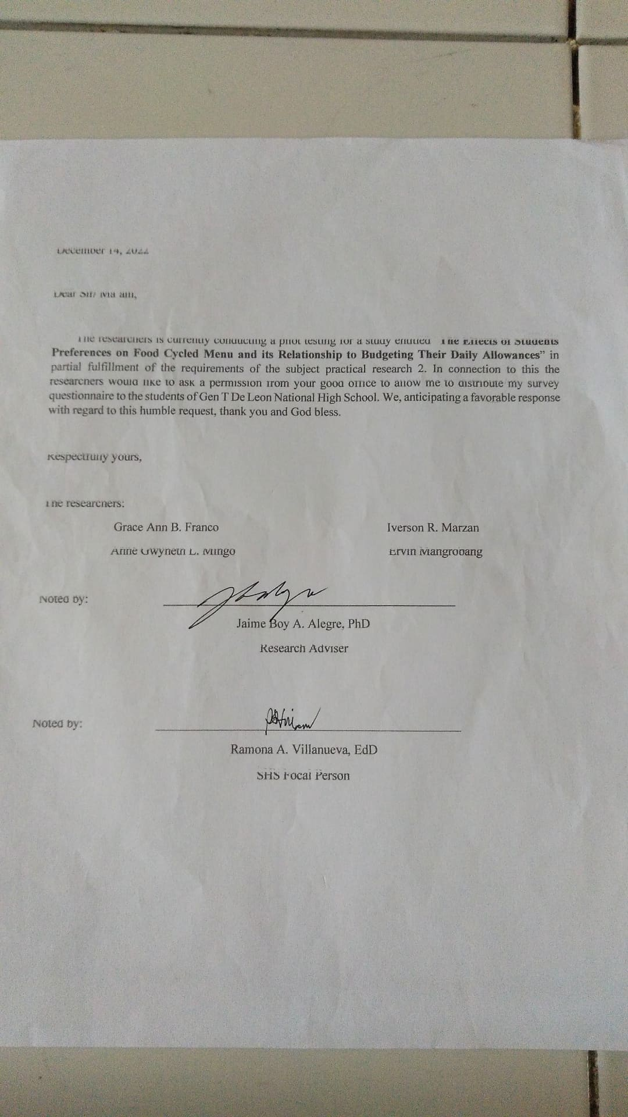

**APPENDIX C**

Page | 42

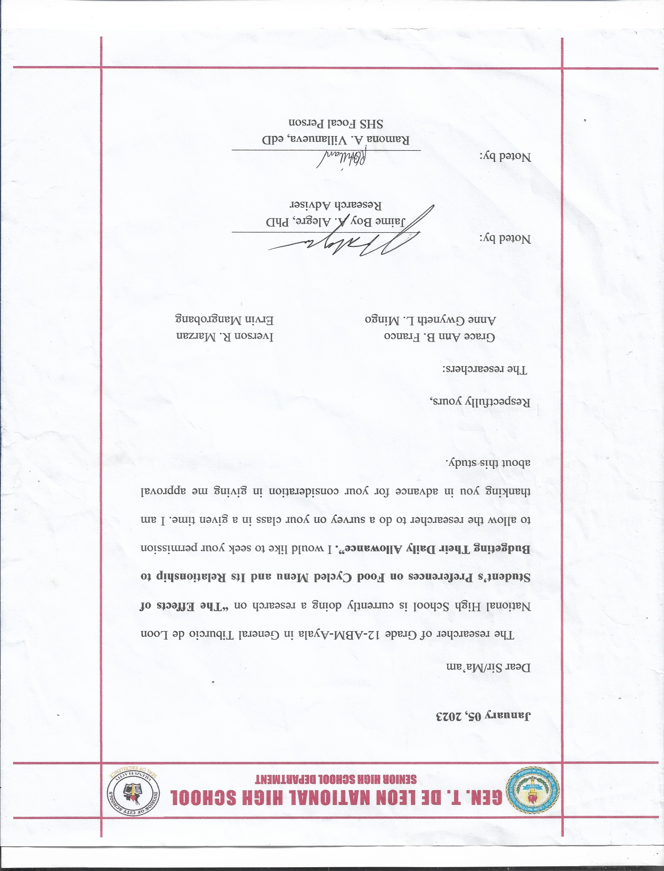

Page | 43

**CURRICULUM VITAE**

Page | 44

**CURRICULUM VITAE** 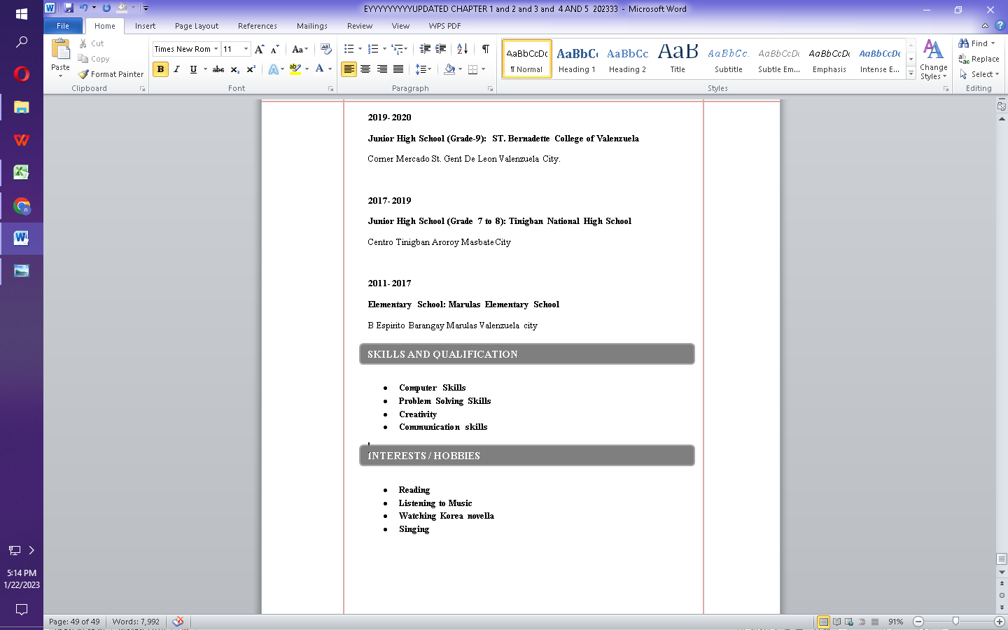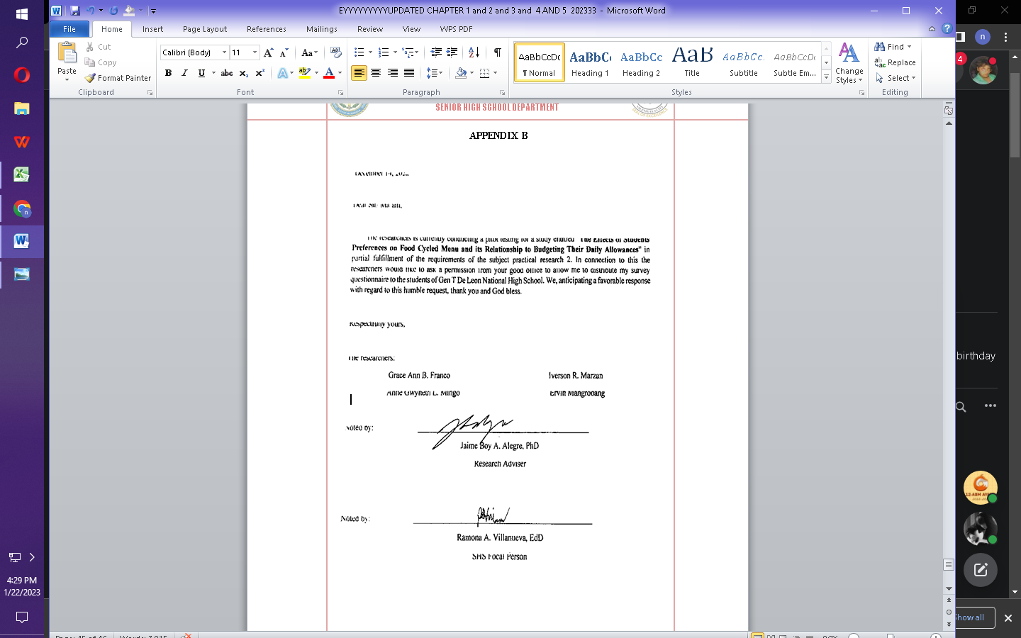



**NAME:** Iverson R. Marzan

**ADDRESS:** 2493 M Delos Reyes Gen Tiburcio Deleon,

Valenzuela City

**MOBILE NUMBER:** (+63)908 143 6621

**EMAIL:** iversonmarzan123@gmail.com

**PERSONAL BACKGROUND:**

**DATE OF BIRTH :** November 14, 2004

**PLACE OF BIRTH :** Karuhatan, Valenzuela City

**SEX :** Male

**CIVIL STATUS :** Single

**CITIZENSHIP :** Filipino

**RELIGION :** Catholic

**Height :** 5’01

**Weight :** 80 kgs

**EDUCATION BACKGROUND:**

**2022-2023 Present**

**Senior High School: Gent De Leon National High School**

Corner Mercado St. Gent De Leon Valenzuela City.

**2020- 2021**

**Junior High School (Grade-10): Gent De Leon National High School**

Corner Mercado St. Gent De Leon Valenzuela City. **Graduated: March, 2021**

**2019- 2020**

Page | 45

**Junior High School (Grade-9): ST. Bernadette College of Valenzuela**

Corner Mercado St. Gent De Leon Valenzuela City.

**2017- 2019**

**Junior High School (Grade 7 to 8): Tinigban National High School**

Centro Tinigban Aroroy Masbate City

**2011- 2017**

**Elementary School: Marulas Elementary School**

B Espirito Barangay Marulas Valenzuela city

**SKILLS AND QUALIFICATION**

* **Computer Skills**
* **Problem Solving Skills**
* **Creativity**
* **Communication skills**

**INTERESTS / HOBBIES**

* **Reading**
* **Listening to Music**
* **Watching Korea novella**
* **Singing**

Page | 46

**CURRICULUM VITAE** 



**NAME:** Grace Ann B. Franco

**ADDRESS:** 1816 Joy St Karuhatan Valenzuela City

**MOBILE NUMBER:** (+63) 995 982 0009

**EMAIL:** francograceee@gmail.com

**PERSONAL BACKGROUND:**

**DATE OF BIRTH :** May 10, 2005

**PLACE OF BIRTH :** Valenzuela Medical Center

**SEX :** Female

**CIVIL STATUS :** Single

**CITIZENSHIP :** Filipino

**RELIGION :** Catholic

**Height :** 4’11

**Weight :** 47 kgs

**EDUCATION BACKGROUND:**

**2022-2023 Present**

**Senior High School: Gent De Leon National High School**

Corner Mercado St. Gent De Leon Valenzuela City.

**2017- 2021**

**Junior High School: Gent De Leon National High School**

Corner Mercado St. Gent De Leon Valenzuela City. **Graduated: March, 2021**

**2011- 2017**

Page | 47

**Elementary School: karuhatan East Elementary School**

**SKILLS AND QUALIFICATION**

* **Communication Skills**
* **Creativity**
* **Accounting Skills**
* **Critical Thinking**
* **Coordination**

**INTERESTS / HOBBIES**

* **Poetry**
* **Singing**
* **Reading**
* **Composing**

Page | 48

**CURRICULUM VITAE** 

**NAME:** Ervin Joshua Mangrobang

**ADDRESS:** 4017 Gen T Road Valenzuela City

**MOBILE NUMBER:** (+63) 968 540 6665

**EMAIL:** ervinjmangrobang@gmail.com

**PERSONAL BACKGROUND:**

**DATE OF BIRTH** : March 12, 2004

**PLACE OF BIRTH :** Tondo Manila

**SEX :** Male

**CIVIL STATUS :** Single

**CITIZENSHIP :** Filipino

**RELIGION :** Catholic

**Height :** 5’9

**Weight :** 60 kgs

**EDUCATION BACKGROUND:**

**2022-2023 Present**

**Senior High School: Gent De Leon National High School**

Corner Mercado St. Gent De Leon Valenzuela City.

**2017- 2021**

**Junior High School: Gent De Leon National High School**

Corner Mercado St. Gent De Leon Valenzuela City. **Graduated: March, 2021**

**2011- 2017**

Page | 49

**Elementary School: Gen T Deleon Elementary School**

**SKILLS AND QUALIFICATION**

* **Accounting Skills**
* **Communication Skills**

**INTERESTS / HOBBIES**

* **Playing Mobile Games**
* **Playing Basketball**

Page | 50

**CURRICULUM VITAE** 



**NAME:** Anne Gwyneth L. Mingo

**ADDRESS:** 3560 F. Clemente Compound Gen. T.

De Leon Valenzuela City

**MOBILE NUMBER:** (+63) 995 667 0183

**EMAIL:** gwynethmingo@gmail.com

**PERSONAL BACKGROUND:**

**DATE OF BIRTH** : October, 11, 2004

**PLACE OF BIRTH :** Valenzuela City Medical Center

**SEX :** Female

**CIVIL STATUS :** Single

**CITIZENSHIP :** Filipino

**RELIGION :** Catholic

**Height :** 5’1

**Weight :** 50 kgs

**EDUCATION BACKGROUND:**

**2022-2023 Present**

**Senior High School: Gent De Leon National High School**

Corner Mercado St. Gent De Leon Valenzuela City.

**2017- 2021**

**Junior High School: Gent De Leon National High School**

Corner Mercado St. Gent De Leon Valenzuela City. **Graduated: March, 2021**

**2011- 2017**

Page | 51

**Elementary School: Gen T Deleon Elementary School**

**SKILLS AND QUALIFICATION**

* **Communication Skills**
* **Creativity**

**INTERESTS / HOBBIES**

* **Singing**
* **Dancing**
* **Drawing**
* **Listening to Music**

We hereby certify that the information stated above is true and correct to the best of our knowledge and belief